**SSL Setup**

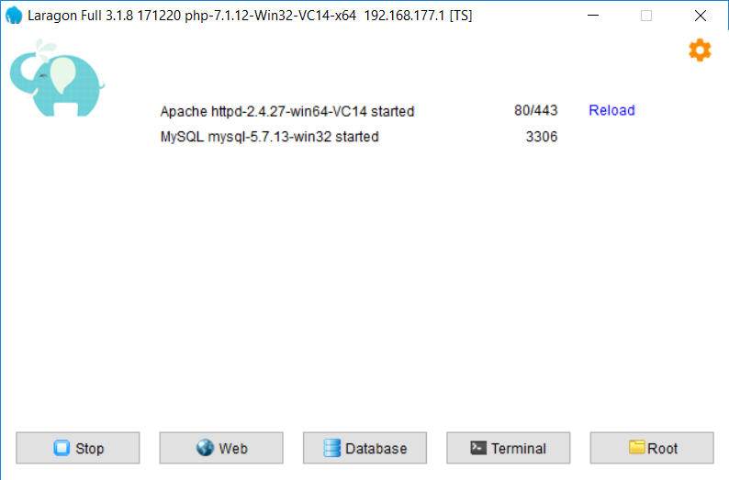

1. Click Here

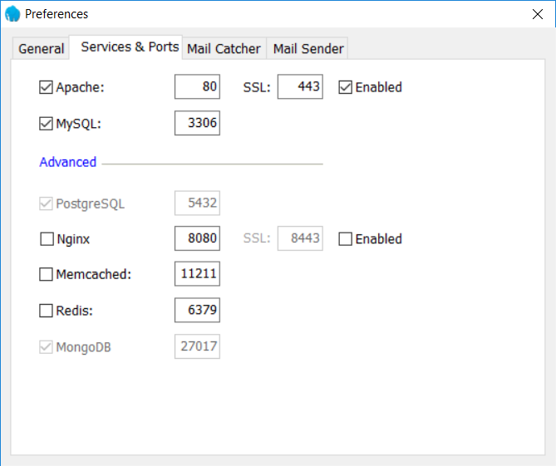

2. Click Enable

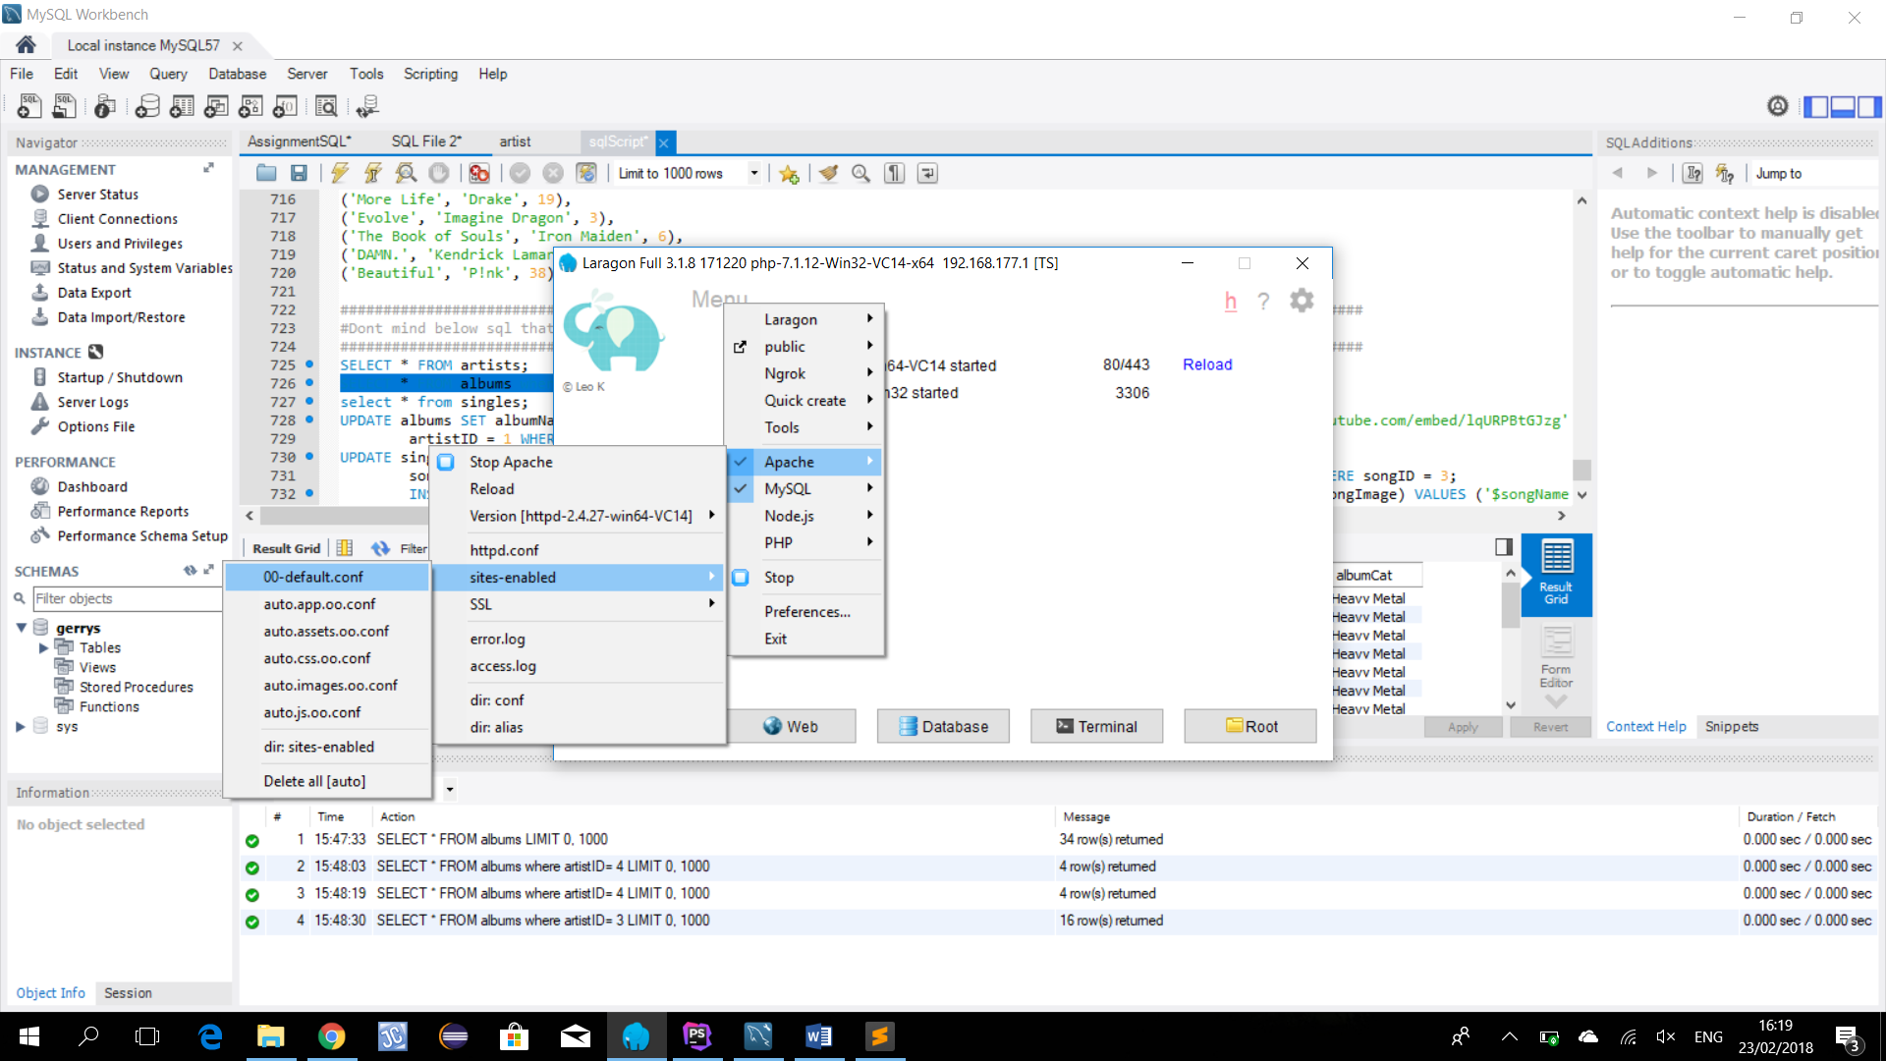

6. Click 00-default.conf

5. Click sites-enable

4. Click Apache

3. Click Menu

**NOTE:** Back up “00-default-conf” file befor editing it otherwise it can mess-up ur laragon I learned the hard way

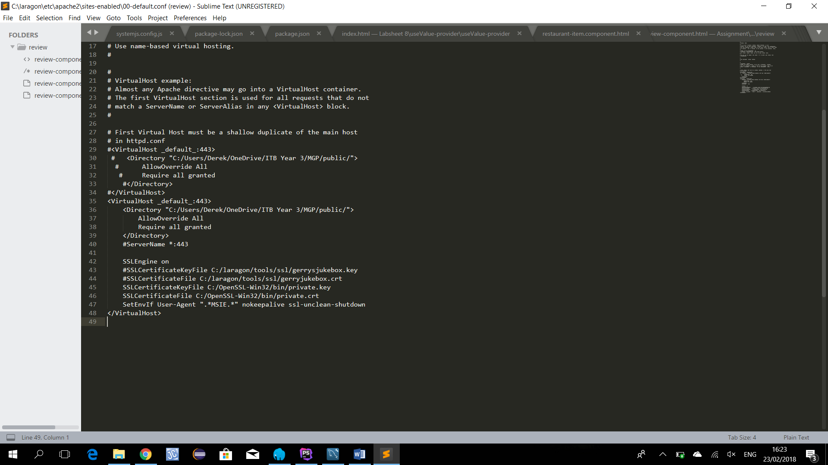

8. Change to your location. **note needs to be in a different location than project folder**

7. Add this block

Don’t need these 2 lines with the ‘#’

Note: The cert and key are located in the “MGP/ssl” folder. To access the https site you need to go to the address “https://localhost:443/”